WATER CONSERVATION

**Introduction**: Water conservation is the practice of using water efficiently and responsibly to ensure its sustainable availability for present and future generations. It involves adopting various strategies and techniques to reduce water wastage, promote responsible water usage, and protect water resources. As a critical component of environmental stewardship, water conservation addresses issues such as drought mitigation, ecosystem preservation, and the equitable distribution of water resources. Through awareness, education, and the implementation of water-saving technologies, communities worldwide can contribute to the conservation and preservation of this precious natural resource.

Water conservation is the practice of using water efficiently to reduce unnecessary water usage. According to Fresh Water Watch, water conservation is important because fresh clean water is a limited resource, as well as a costly one.

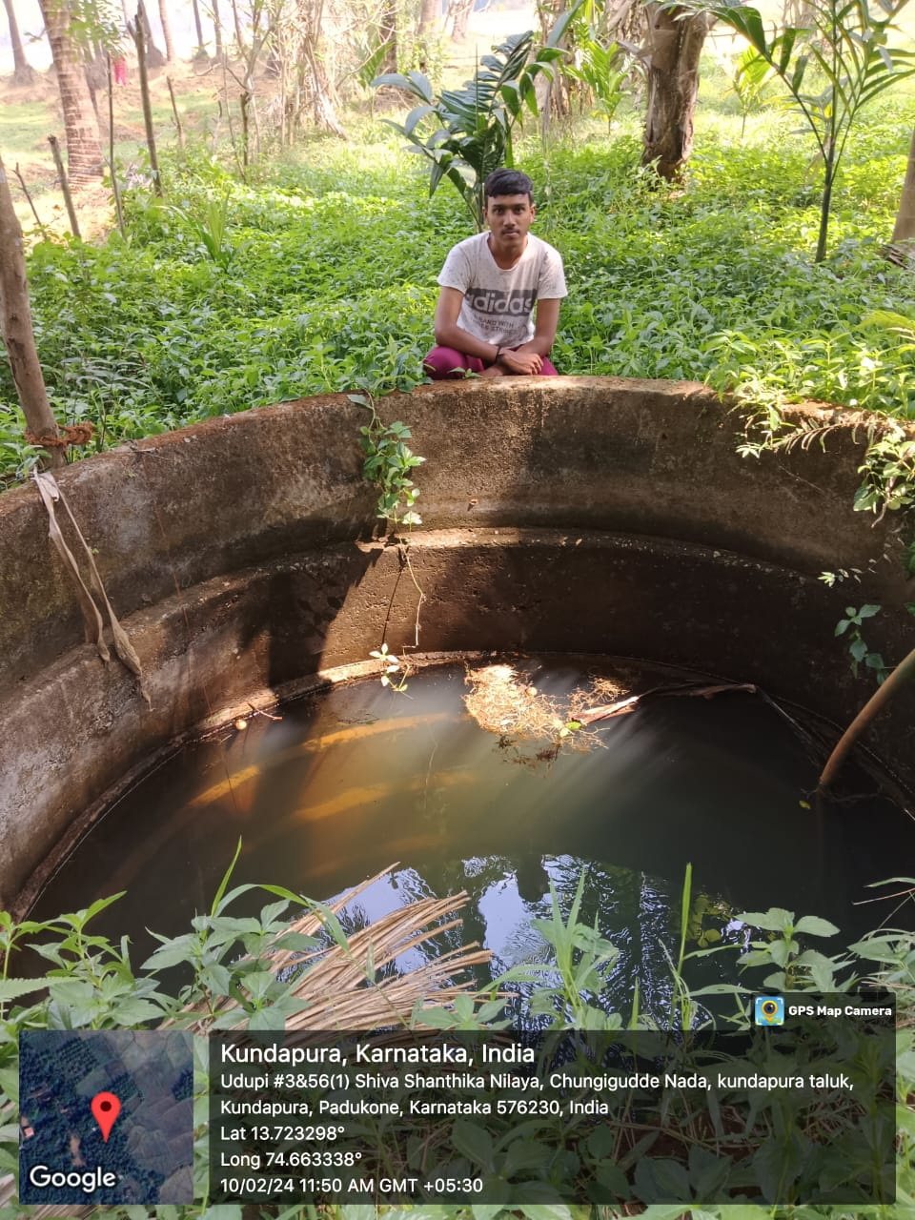

**Importance of Water Conservation In, the Present days:**

Growing Population: With the world's population continuously increasing, the demand for water,

escalates, putting pressure on existing water supplies. demand for water escalates, putting pressure on existing water supplies.

demand for water escalates, putting pressure on existing water supplies.

Climate Change: Climate change is altering precipitation patterns and increasing the frequency of extreme weather events, leading to droughts in some regions and floods in others.

Ecosystem Preservation: Aquatic ecosystems, including rivers, lakes, and wetlands, rely on sufficient water flow to sustain biodiversity and ecosystem service.

Energy Savings: Water treatment and distribution require significant energy inputs. By conserving water, we also reduce the energy needed for pumping, treating, and heating water, leading to lower carbon emissions and energy costs.

**Conserving well water is crucial for sustainable water management. Here now we can see how to conserve well water**:

Fix Leaks: Regularly check for leaks in your plumbing system, faucets, toilets, and irrigation lines. Fixing leaks promptly can prevent water wastage.

Install Water-Saving Devices: Install low-flow faucets, showerheads, and toilets to reduce water usage without sacrificing functionality.

Water Efficiently: Water your lawn and garden during the coolest parts of the day to minimize evaporation. Use drip irrigation systems or soaker hoses instead of overhead sprinklers to deliver water directly to the roots where it's needed most.

Collect Rainwater: Set up rain barrels or cisterns to collect rainwater from your roof for use in watering plants and gardens.

Regular Maintenance: Maintain your well system by scheduling regular inspections and servicing to ensure it operates efficiently and doesn't waste water.

By implementing these strategies, we can conserve well water.

**CONCLUSION**

prioritizing well water conservation is essential for preserving vital groundwater resources, sustaining ecosystems, and ensuring water security for present and future generations. Implementing efficient water management practices is critical to mitigate depletion and contamination risks, fostering environmental resilience and human well-being.